AI is often categorized into three main types: Narrow AI (ANI), General AI (AGI), and Super AI (ASI). Narrow AI, also known as weak AI, excels at specific tasks but struggles with anything outside its designed scope. General AI, on the other hand, aims to replicate human-level intelligence, capable of learning and performing a wide range of tasks. Super AI is a hypothetical future stage of AI that surpasses human intelligence in every way, potentially in all cognitive areas.
1. Narrow AI (ANI):
- Definition: AI systems designed to perform specific tasks or a narrow range of related tasks.
- Examples: Virtual assistants (Siri, Alexa), image and speech recognition, recommendation engines, and self-driving cars.
- Limitations: Lacks the ability to generalize or adapt to new, unfamiliar situations.
2. General AI (AGI):
- Definition:
AI that can understand and learn any intellectual task that a human being can.
- Capabilities:
Possesses human-level cognitive abilities, including problem-solving, decision-making, and creativity.
- Current Status:
AGI is currently a theoretical concept, and we are still developing AI systems that can perform specific tasks with human-like intelligence, according to Google Cloud.
3. Super AI (ASI):
- Definition: AI that surpasses human intelligence in all aspects.
- Potential: Capable of performing tasks that humans find challenging or impossible, including emotional intelligence, creativity, and strategic planning.
- Challenges: Raises ethical and existential questions about control, safety, and potential societal impacts.

Key Similarities Between Narrow, General, and Super AI
Artificial intelligence (AI) allows machines to learn from previous experiences, adjust to new inputs or stimuli, and perform human-like tasks with better efficiency. AI has been adopted across diverse industry verticals ranging from finance, healthcare, and aviation to manufacturing and supply chains.
While narrow AI has become part of our day-to-day lives, AGI is still in its early stages, and the hype around ASI is tremendous and unwavering. However, all these types of AI have evolved from the same roots and have certain undeniable similarities.
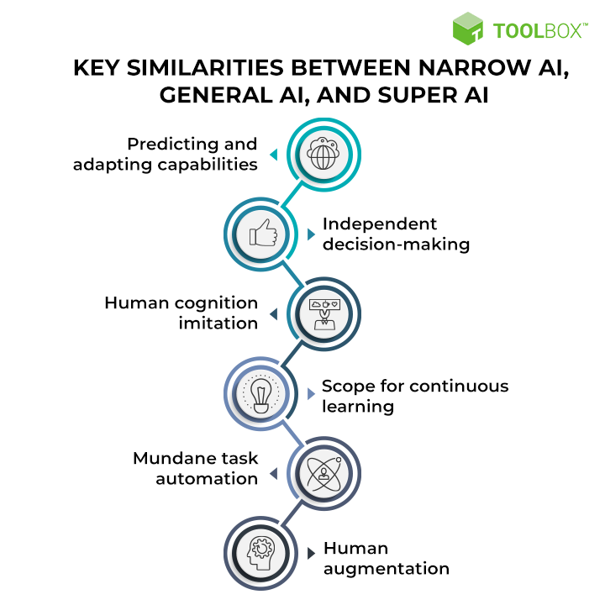
Key Similarities Between Narrow AI, General AI, and Super AI
Let’s understand the key similarities between ANI, AGI, and ASI.

1. Capability to predict and adapt
All types of AI use algorithms to identify and discover patterns in data. The identified patterns are then used by AI solutions to learn and adapt, much like how humans learn from repetitive tasks. All the analyzed data is further used to make future decisions and derive meaningful predictions.
Various software systems used today, such as systems used to correct spelling errors, predict what the user is going to type, or to give the user the shortest route to their destinations, have machine intelligence functioning at their core.
The same principle applies to autonomous vehicles that make navigational decisions based on traffic and surrounding data. The field of law presents asimilar application, where an AI solution reviews several documents and flags the relevant ones to a particular case. Upon flagging the relevant document, algorithms can then easily find similar documents. Such AI applications can also be used for litigation prediction, as they can evaluate the risk factors of cases based on document content and predict judgment outcomes.

2. Make decisions on their own
AI augments human intelligence, delivers insights from gathered data, and also learns to enhance overall productivity. AI’s ability to analyze data, self-learn, gain insights, and make improved decisions makes it a powerful tool, irrespective of the application.
Current narrow AI solutions make their own decisions based on the data that has been programmed into them. On similar lines, with in-built human-like cognitive abilities in AGI and ASI, future AI solutions may invariably make more thorough decisions that are optimal and faster than their human counterparts.

3. Imitate human cognition
All kinds of AI systems essentially imitate the human mind and solve complex issues. They effectively comprehend the world and respond appropriately, much like humans studying their surroundings, deriving inferences, and then interacting with them properly.
Narrow AI’s machine intelligence uses natural language processing (NLP) to understand speech and text in natural language. This is evident in chatbots and virtual assistants such as Cortana. Current AI is thus programmed to imitate human cognition to interact with humans in a natural and personalized manner. As AGI and ASI systems are advanced versions of ANI, this imitation of human cognition can only be expected to expand and progress further going ahead.

4. Continually learn and evolve
AI refers to a machine’s ability to learn from common data patterns. AI systems use deep learning, which is a subset of machine learning, to continually learn and evolve. Most deep learning methods, often referred to as deep neural networks, use neural network architectures and are trained by using large sets of labeled data. Here, ‘deep’ represents the number of hidden layers in the neural network. Compared to traditional neural nets with two to three hidden layers, deep neural nets have close to 150 layers.
Currently, the most familiar examples of deep learning include Amazon’s Alexa, Google Assistant, and Samsung Bixby. Such AI systems use algorithms to develop analytical models and perform tasks by undertaking numerous rounds of trial and error.
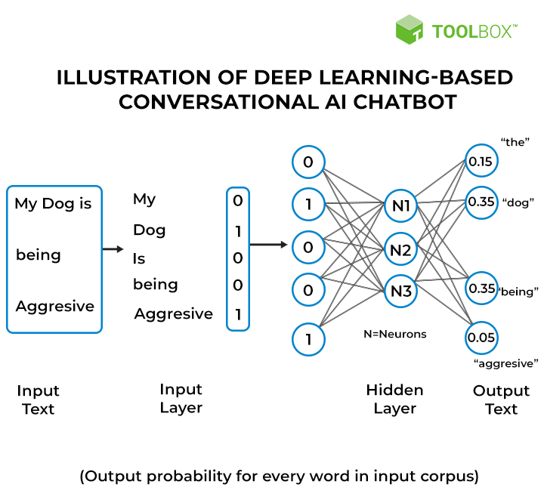
Illustration of Deep Learning-based Conversational AI Chatbot

5. Eliminate mundane tasks through automation
All types of AI replace routine and mundane tasks in an organization by offering automated solutions. This allows employees to focus on critical tasks.. Smart warehouses are fitted with all necessary automation and AI systems that free employees from the worry of moving heavy objects. Rather, automated robots are equipped to perform these activities. Moreover, inventory is also automatically calculated, leaving employees to handle tasks requiring human attention, such as ensuring that automated systems operate properly. This boosts efficiency and saves the time and effort of employees while reducing overhead expenses.
With AGI and ASI along the horizon, activities that require careful human monitoring will also be taken up by intelligent agents that showcase superior intelligence as compared to humans in the future.

6. Facilitate human augmentation
A combination of AI and people can bring different abilities and strengths together. Augmented intelligence takes any form of AI to higher levels. Consider the example of IBM’s Deep Blue, a computer that defeated chess grandmaster Garry Kasparov in the late 1990s. After losing, Garry experimented on how a computer helper can lead to raising the level of chess played by only a human or a computer. He discovered that humans, machines, and a good process, can result in better outcomes than a single, strong computer.

Today’s narrow AI has been quite effective in helping humans complete critical tasks. With AGI and ASI in near sight, technologies such as automation may further increase the effectiveness of human intelligence. This would imply the overall output of ‘human intelligence plus machine intelligence’ will be superior to that of a human or machine alone.
See More: What Is Artificial Intelligence (AI) as a Service? Definition, Architecture, and Trends

Key

Narrow AI vs. General AI vs. Super AI: Key Differences
Most people would have heard about AI in Hollywood blockbusters such as the Terminator franchise. The AI systems in fiction have been envisioned as malicious entities that would take over the world by outperforming human intelligence. Do you really think that AI systems like ChatGPT would enslave humanity in future? The narrow AI vs general AI vs super AI debate may help you find some effective answers to such questions.
Artificial intelligence has empowered machines to simulate human intelligence for solving problems and making decisions. It leverages algorithms and technologies such as machine learning, natural language processing, and deep learning to understand and respond to different tasks like humans. It is also important to note that the AI you witness today is narrow AI or weak AI that would evolve further and create new variants of AI. Let us learn more about the three notable types of AI and the differences between them.
Start your AI journey with the leading AI Certification Course offered by us. Deep dive into AI’s practical applications and discover the best career path.

Understanding the Three Variants of AI
You can understand the evolution of AI by identifying the fundamental details about the three notable types of artificial intelligence. The answers to queries like ‘What is narrow AI and general AI and super AI?’ can help you find the first point for comparing the three types of AI. Each type of AI has different capabilities and can influence the economy and society in unique ways. Here is an overview of the three most prominent variants of artificial intelligence.
- Artificial Narrow Intelligence
Artificial narrow intelligence or ANI is popular as weak AI or narrow AI. It can help in working on specific applications or tasks only. The working principle of narrow AI revolves around programming AI models for individual tasks like speech recognition, autonomous vehicle driving, facial recognition, or language translation. Narrow AI tries to replicate human behavior in machines on the basis of specific contexts, parameters and constraints. The most noticeable example of narrow AI points at the speech recognition systems used in virtual assistants on smartphones.
- Artificial General Intelligence
The concerns of limitations in narrow AI create curiosity regarding the possibilities of creating advanced AI systems to address them. The difference between narrow AI and general AI clearly indicate how artificial general intelligence would be better than narrow AI. Artificial general intelligence or AGI represents the next stage in the evolution of AI that would empower machines to learn, think, understand and apply their knowledge to solve problems like humans. It would help AI systems recognize the beliefs, thought processes and beliefs of other intelligent systems.
- Artificial Super Intelligence
Artificial super intelligence or ASI is the futuristic vision for AI systems that would exceed human intelligence. ASI systems or super AI can understand human sentiments and can also develop their own beliefs, desires and emotions. As of now, artificial super intelligence is still a hypothetical concept. The arrival of super AI would empower AI systems with problem-solving and decision-making capabilities that are better than those you would expect from human beings.

Discovering the Similarities between Narrow AI, General AI, and Super AI
Artificial intelligence is the common thread that holds narrow AI, general AI, and super AI on the same line. It is important to note that the narrow general and super AI have the same roots, thereby sharing some crucial similarities. The three types of AI may have significant differences in the level of intelligence they bring to the table albeit with similarities in their core approaches and principles. For instance, all the three types of AI need massive datasets for the training process.
The three types of AI leverage algorithms for identifying and discovering different patterns in data. AI systems can use the patterns for learning and adapting continuously, similar to the ability of humans for learning from different experiences.
Artificial intelligence also enhances human intelligence with the help of insights from data. The most distinct highlight of all types of AI is their ability to make decisions without human intervention. Narrow AI can make decisions independently on the basis of data programmed in their algorithms. General AI and super AI may take decision-making to the next level with better efficiency than humans.
The similarities in a narrow AI vs general AI comparison also draw attention towards the capability of different types of AI for continuous learning. Every variant of AI focuses on learning from new experiences for evolving continuously to come up with advanced variants.
Another notable similarity between the three different types of AI is the ability to reduce repetitive tasks through the power of automation. Artificial intelligence can serve as a valuable partner for different tasks with the power of automation. The three different types of AI can help in augmenting the capabilities of humans for various tasks across different industries.
We bring the brand new AI for Everyone Free Course. Familiarize yourself with the fundamentals of AI and build a strong foundation.

Unraveling the Differences between Narrow AI, General AI and Super AI
The latest technological advancements in AI have made our lives easier with smart voice assistants, AI chatbots and self-driving cars. Narrow AI has become an integral part of everyday lives of people in many ways. On the other hand, general AI and super AI are waiting their turn to transform the AI landscape with innovative and powerful solutions.
Here is an overview of the differences between narrow AI, general AI, and super AI.
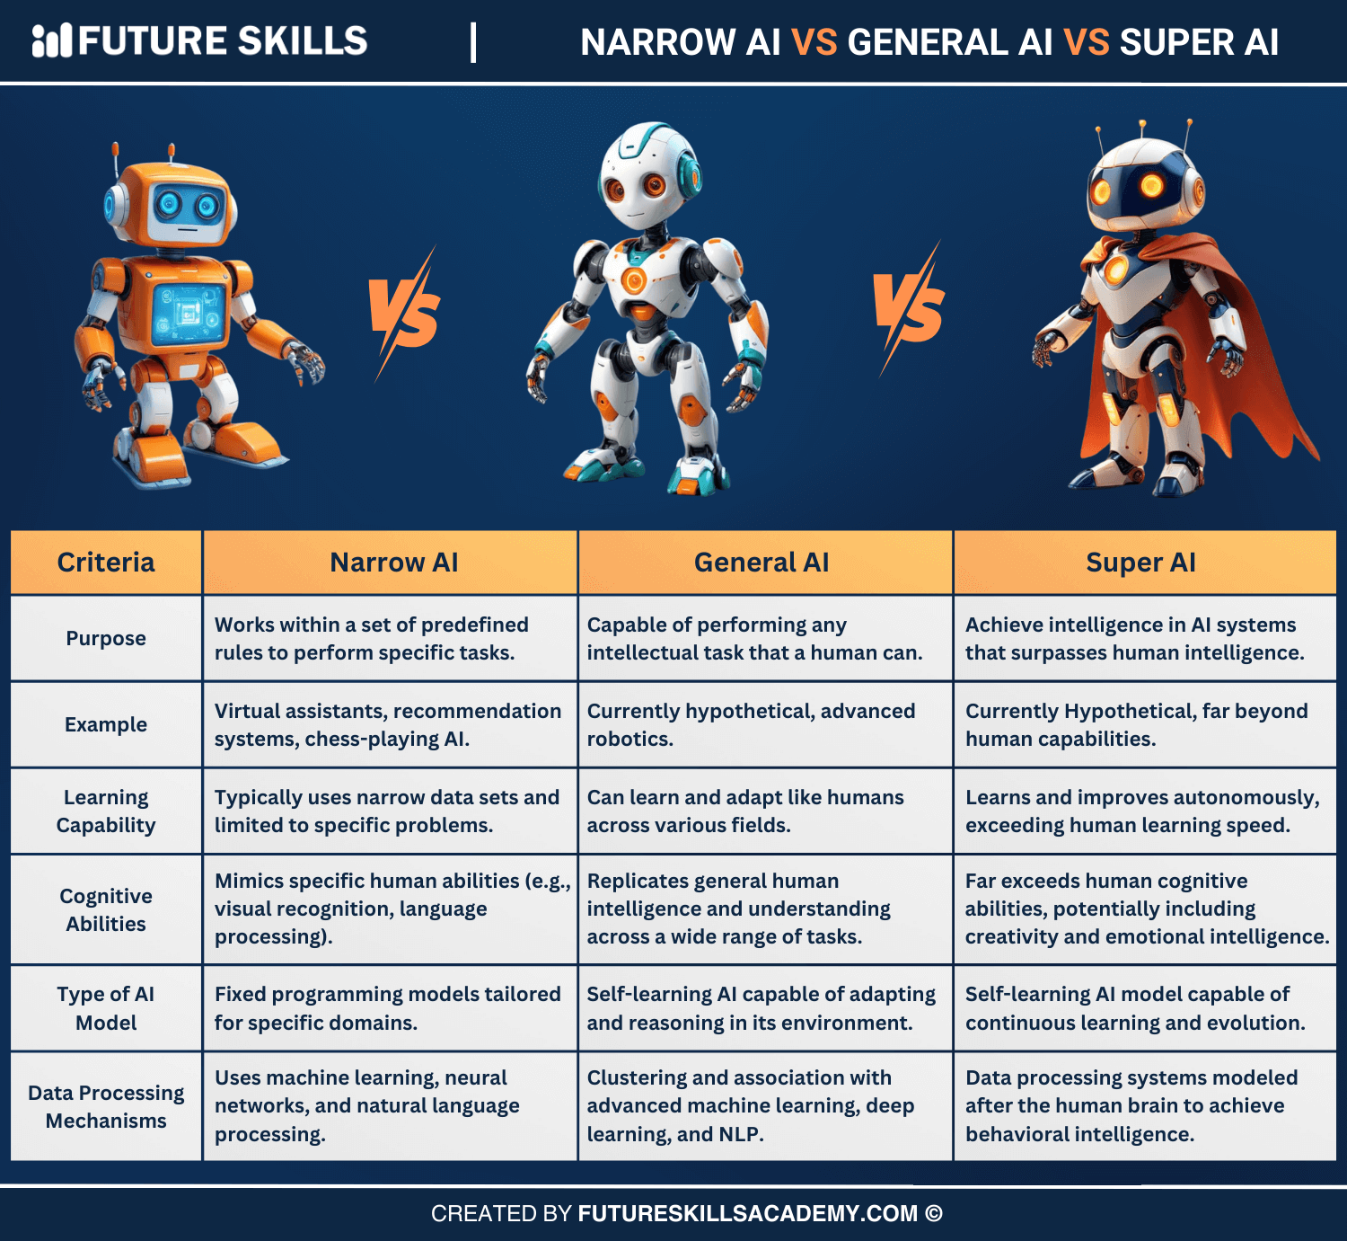

differences between ANI, AGI, and ASI.

Category | Narrow AI | General AI | Super AI
Definition | Narrow AI is focused on a specific, singular, or focused task and lacks the self-expansion functionality to solve unfamiliar problems. | Strong AI can perform a broad range of tasks, reason, learn, and improve cognitive capabilities comparable to humans. | Super AI demonstrates intelligence beyond human capabilities.
Purpose | Narrow AI is programmed to operate within a set of pre-defined functions to complete or address a specific problem. | Strong AI will have a mind of its own and will be able to accomplish any type of task that its ‘mind’ can envision. | Super AI will surpass human intellect to accomplish any task better than its human counterparts.
AI Model | Narrow AI uses fixed domain models that are programmed. | Strong AI self-learns and reasons with its operating environment. | Super AI self-learns and evolves with a consciousness of its own.
Awareness | Narrow AI lacks self-awareness, artificial consciousness, or cognitive abilities. | Strong AI will be considered truly advanced, intelligent, and fully self-aware, implying that it will possess common sense, creativity, and the ability to express emotions. | Super AI will simulate human reasoning and experiences to develop an emotional understanding, beliefs, and desires of its own.
Data Processing | Narrow AI classifies data by using machine learning, natural language processing, artificial neural networks, and deep learning. | Strong AI leverages clustering and association by using advanced versions of machine learning, deep learning, NLP, and artificial neural networks. | Super AI may use the human brain as a model to elicit behavioral intelligence and understand and interpret human emotions and experiences.
Knowledge Transfer | Narrow AI does not facilitate knowledge transfer to other domains or tasks. | Strong AI leverages knowledge transfer to new domains and tasks. | Super AI will invariably exercise knowledge transfer across tasks and domains.
Implications | Narrow AI outperforms humans in specific repetitive tasks such as driving, medical diagnosis, and financial advice. | Strong AI competes with humans across all endeavors, from earning university degrees to handling medical emergencies. | Super AI outperforms humans to achieve societal objectives and facilitate space exploration, but also threatens the very existence of the human race.
AI Stage | Today’s AI | Future AI – around 2040 | Soon after AGI
Since the inception of AI in the mid-20th century, all that we have managed to achieve is the paradigm of narrow AI. It performs tremendously well when it comes to accomplishing designated tasks. Once narrow AIgets as sophisticated as the human brain, we may touch the realm of AGI.

- Purpose of the AI System

The first parameter to compare narrow AI, general AI and super AI is their purpose. It is important to begin a narrow AI vs general AI vs super AI comparison with a review of their purpose to determine the utility of each variant. The definitions of the three types of AI provided a basic impression of their purpose.
Narrow AI is the ideal option for specific tasks focused on a particular niche to resolve new problems. The working of narrow AI involves programming algorithms to work according to a set of pre-defined rules. It cannot expand independently to add new functionalities for addressing a specific problem.
Strong AI is capable of performing a broad range of tasks with the flexibility for reasoning, learning and improving cognitive abilities similar to that of humans. The utility of strong AI will be more than narrow AI as it can have the power of independent thinking. Strong AI can be capable of achieving any type of task that requires human intelligence without relying on niche datasets.
The purpose of super AI primarily focuses on achieving intelligence that surpasses human intelligence. The superior cognitive and reasoning capabilities can empower super AI to accomplish any task with better productivity and efficiency than humans.
- Types of AI Models Used for Operations
The types of AI models are the most critical parameters for comparing narrow AI, general AI and super AI. Comparison of the types of models underlying the three types of AI can provide a glimpse of their effectiveness.
Narrow AI relies on programmed AI models that are tailored for specific domains. The models used in narrow AI are limited in terms of their capabilities to solve tasks outside the concerned domain.
The difference between narrow AI and general AI points out how general AI uses models with the capability for self-learning. General AI models have the power for reasoning like humans in the operating environment.
Super AI would deploy the most advanced AI models that can learn and evolve independently. As a matter of fact, AI models underlying super AI systems can also develop their own consciousness.
- Data Processing Mechanisms
Every AI system relies on data to learn and work like humans or even better than them on different tasks. The comparison between data processing mechanisms can help you understand the driving forces of each type of AI.
Narrow AI relies on technologies such as machine learning, neural networks, deep learning and natural language processing for data classification.
Strong AI or general AI leverages association and clustering methods through advanced machine learning, neural networks, NLP and deep learning.
Super AI depends on modeling data processing systems according to the human brain for achieving behavioral intelligence. The data processing mechanism underlying super AI helps in effective interpretation of human experiences and emotions.

Final Thoughts

The onset of the AI revolution has introduced the world to the many wonders of artificial intelligence. Responses to queries like ‘What is narrow AI and general AI and super AI?’ create curiosity regarding the different types of AI and their capabilities. The three types of AI represent significant milestones in the evolution of artificial intelligence with unique value propositions. Discover more about the differences between them to determine their significance for the broader AI landscape now.

